**Converting OS based program into Menu Driven Program using Python**

This task is given by Vimal Daga sir in which we have to convert the operating system(OS) based program into menu driven program using Python Code which will excecute the query when user given the input as a text.

Task:

1. We import the os and pyttsx3 library in our program .
2. Then, we create a one variable which will help us to take user input.
3. We use use “while” loop to continue our process.
4. We take nested loop in it to take “os” program what we have to run through this program.

Software Required:

* Anaconda

Details:

In python code we import “os” library file because with the help of this library file python will be able to launch the “os” program . It means python is working as a bridge between operating system and human beings without this library file python is unable to launch “os” program.Here, we import one more library i.e, pyttsx3 using this file we can use our operating system speaker to speak a text what we have written in our code. With the help of this python we can run or launch the os based program easily and very effective way.

Working Process:

The working process as follow:

* 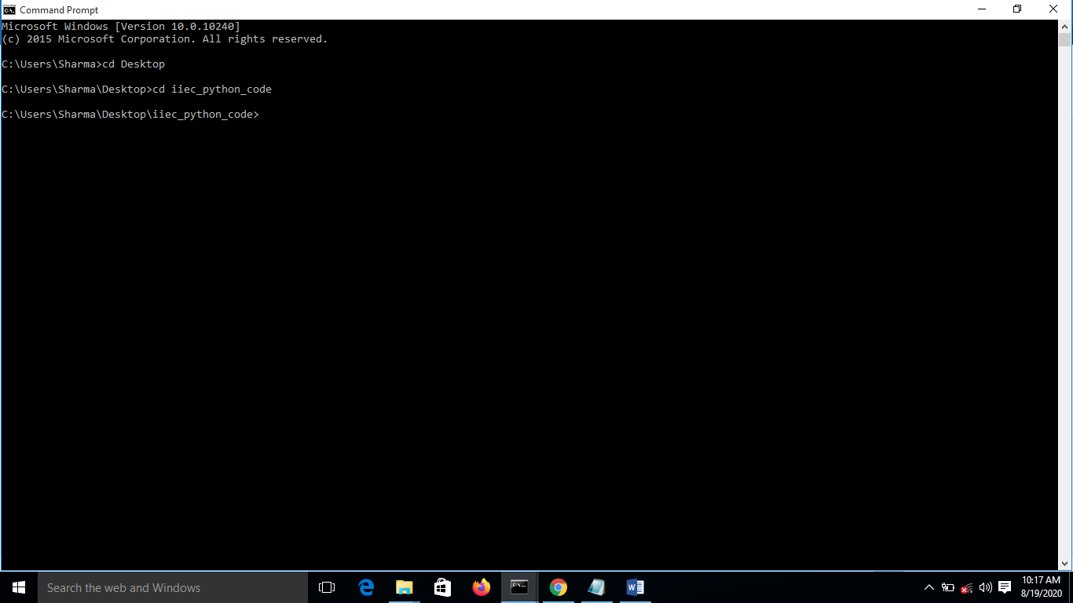First we add directory where our code is saved
* 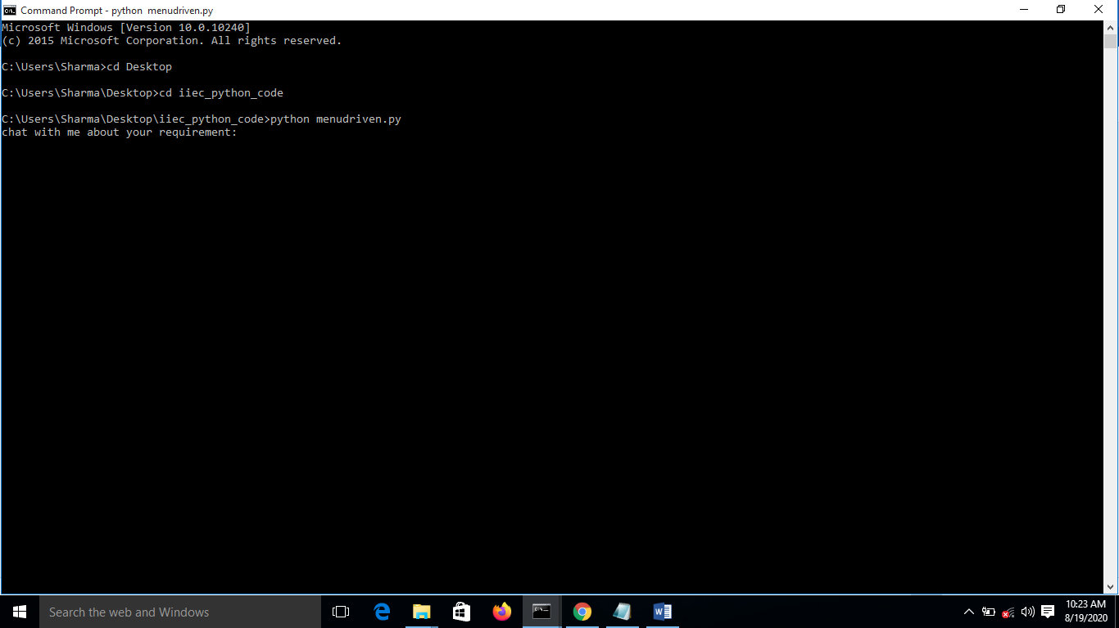Now we run our python code
* After running python code we our able to launch os based system using python

1. 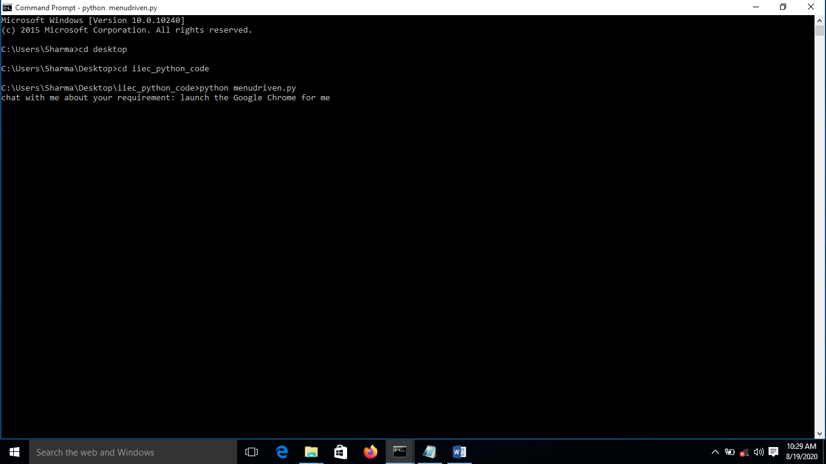Google Chrome

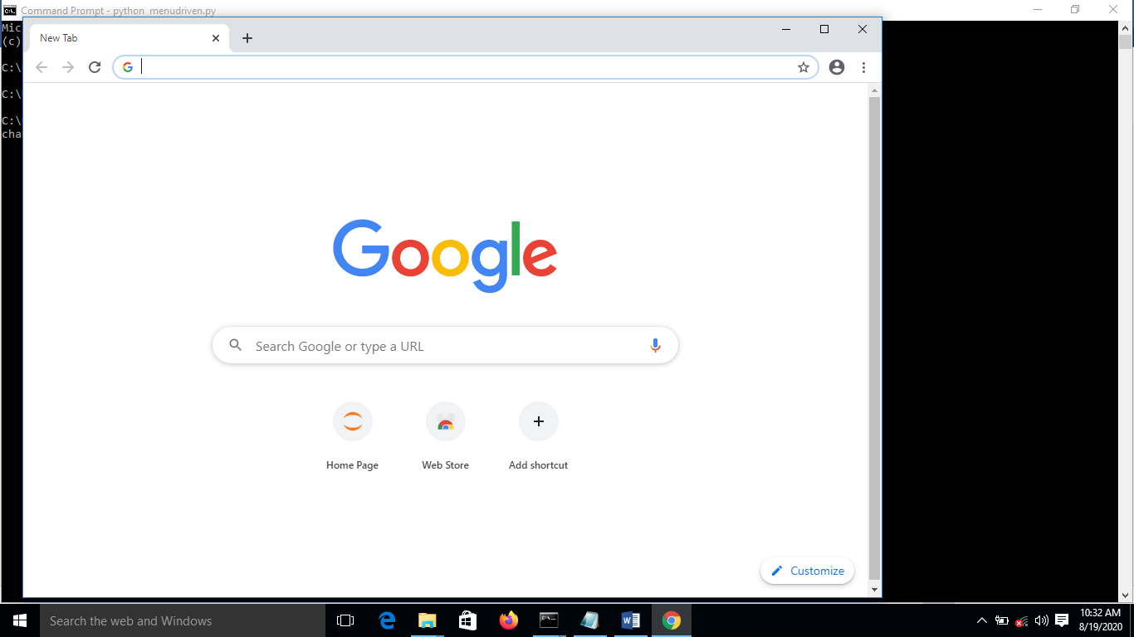After hitting enter Google chrome will launch,

1. Calculator

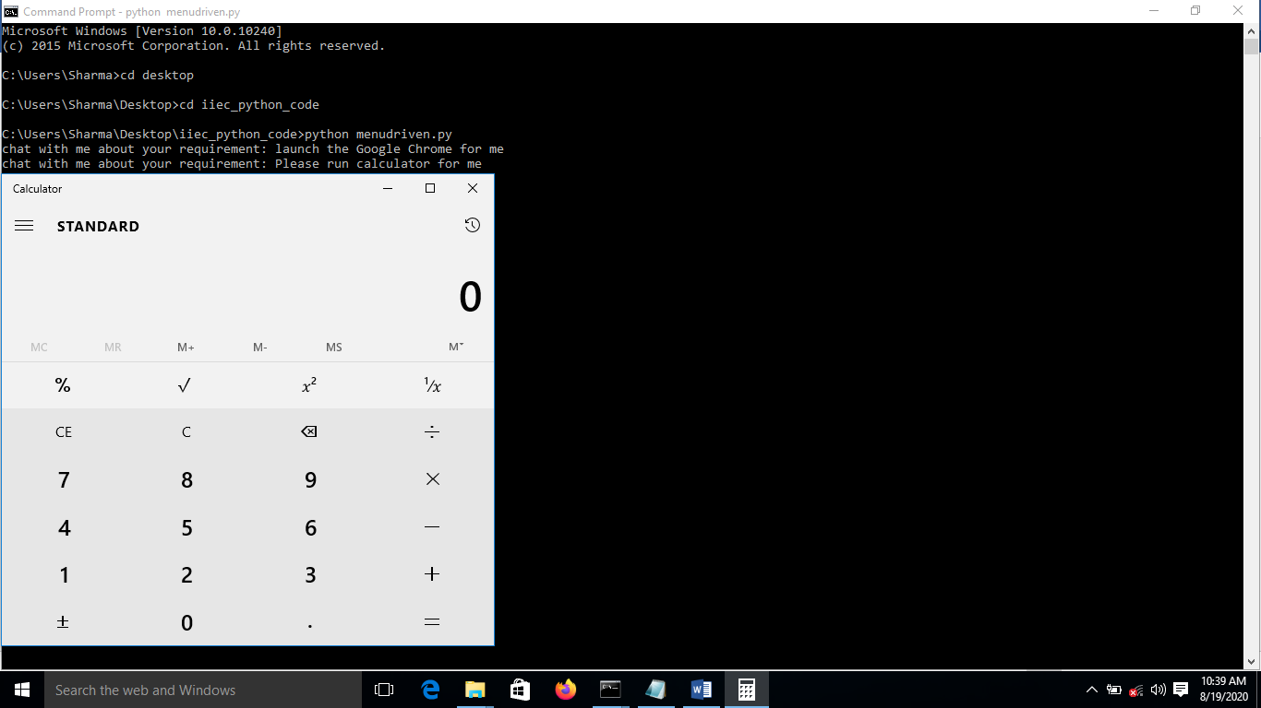

1. Windows Store

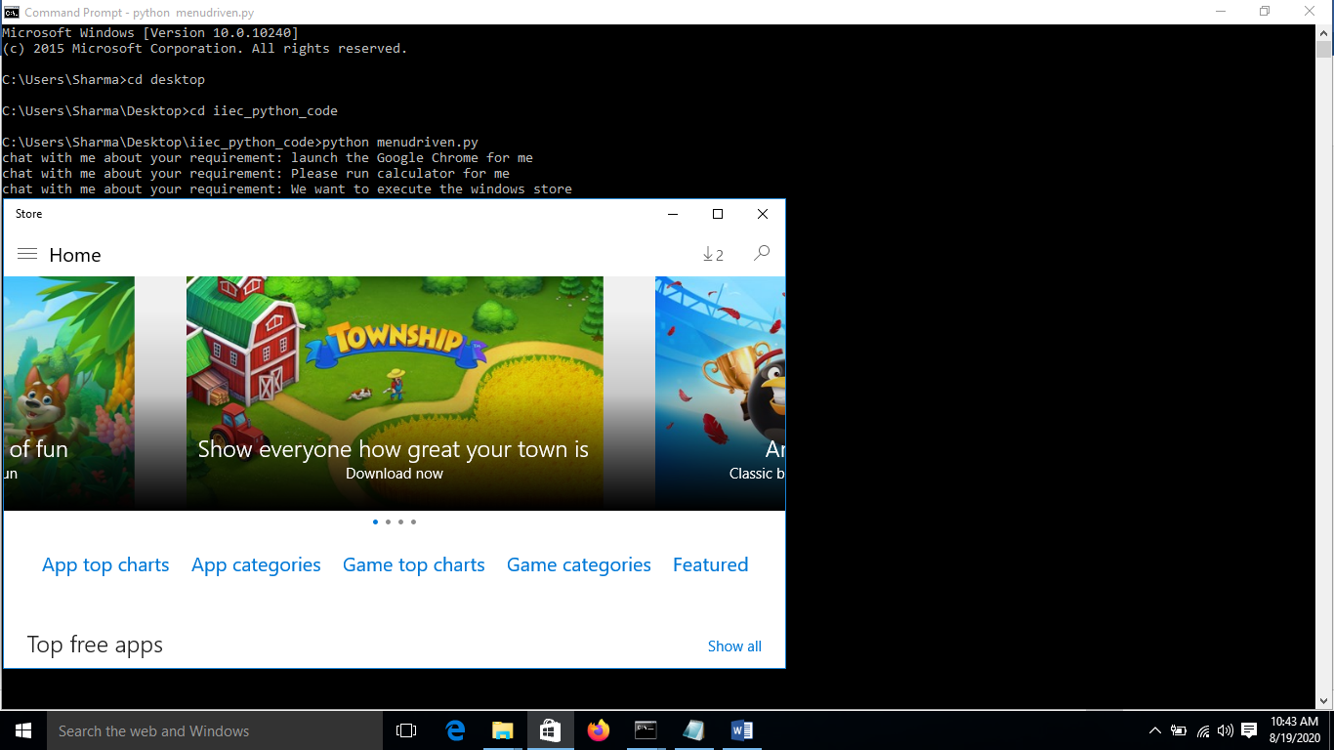

* 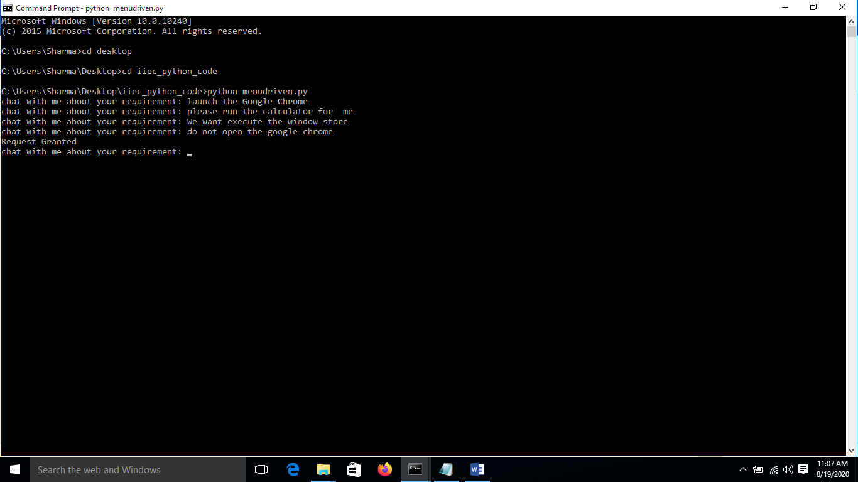If we don’t want run any software then it generate a message that your request granted .
* 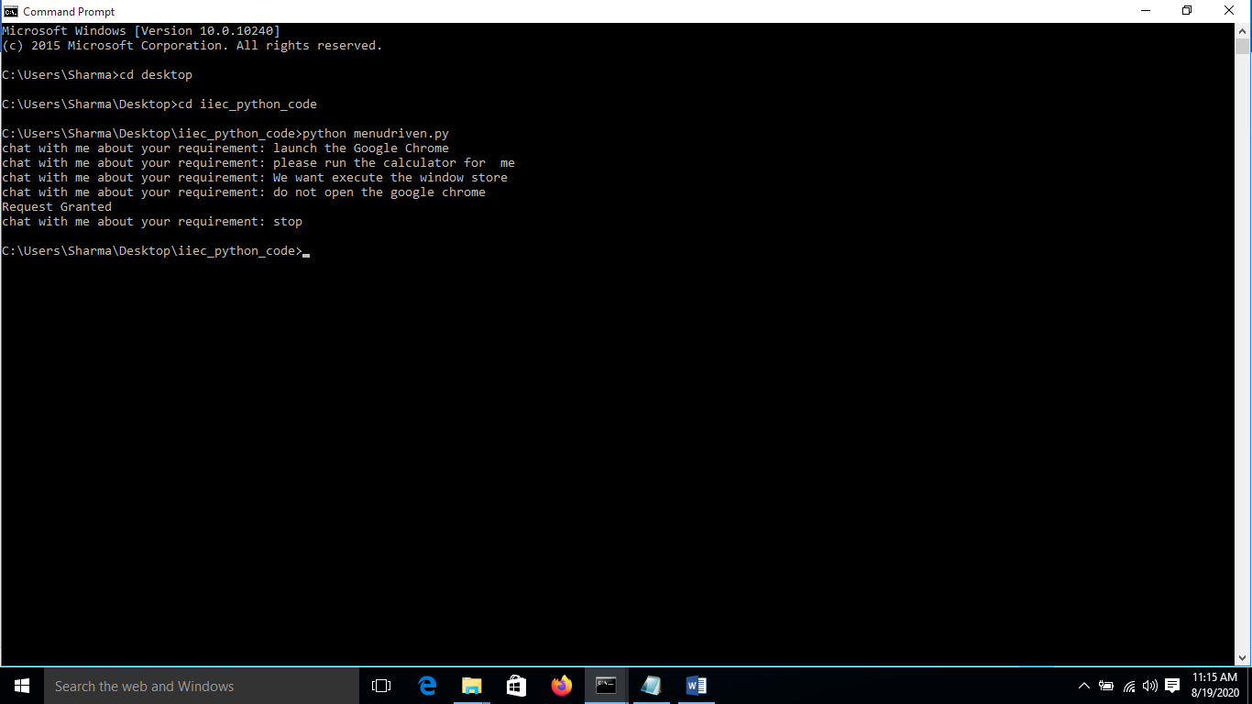If we open one software then we close it our task is ready for execute the next query i.e to launch the new software.To terminate this we have to type “exit” or “stop” and then our task will stop .

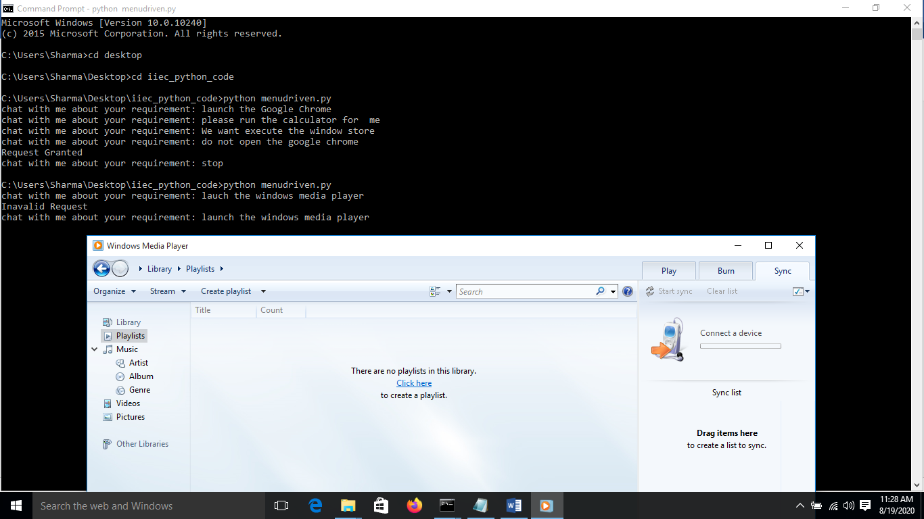NOTE: We can launch many “os” based program like we launch camera, calculator, Mozilla Firefox, Internet Explorer, File Explorer, Skype, MS Word, Powerpoint , Excel, Notepad, Windows Store ,Control Panel ,Window Media Player, VLC Player etc.

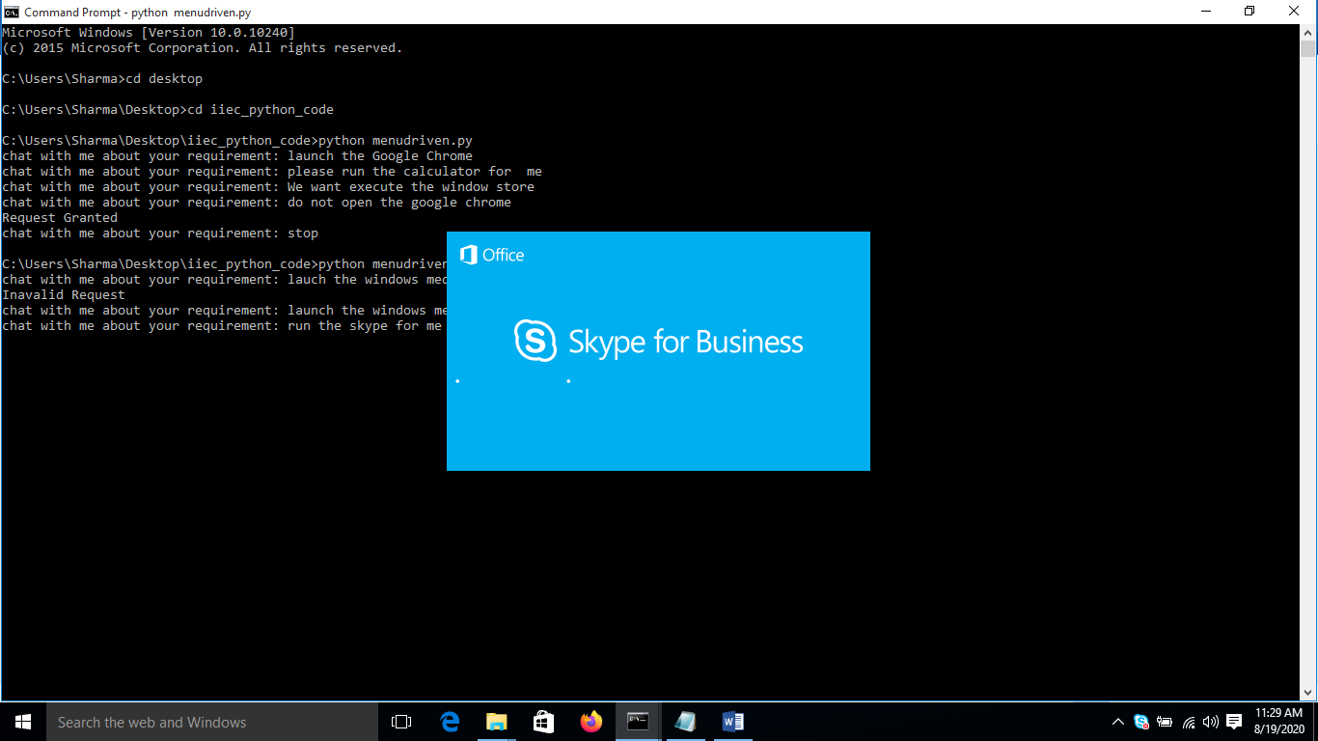

That’s all from my side .